**Census 2021 – Gender Identity question**

This local authority map shows the total responses that answered ‘no’ to the question “Does your gender identity match your sex assigned at birth”.

This was a voluntary question and only included those over the age of sixteen. The headline result is that 0.41% of the population of Wales fall under the ‘trans’ umbrella. 6.32% did not answer the question.

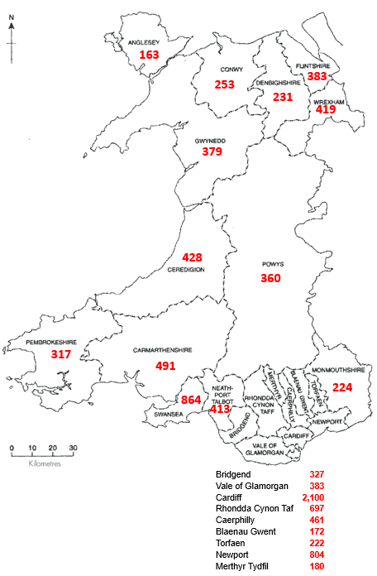

Wales Council for Voluntary Action