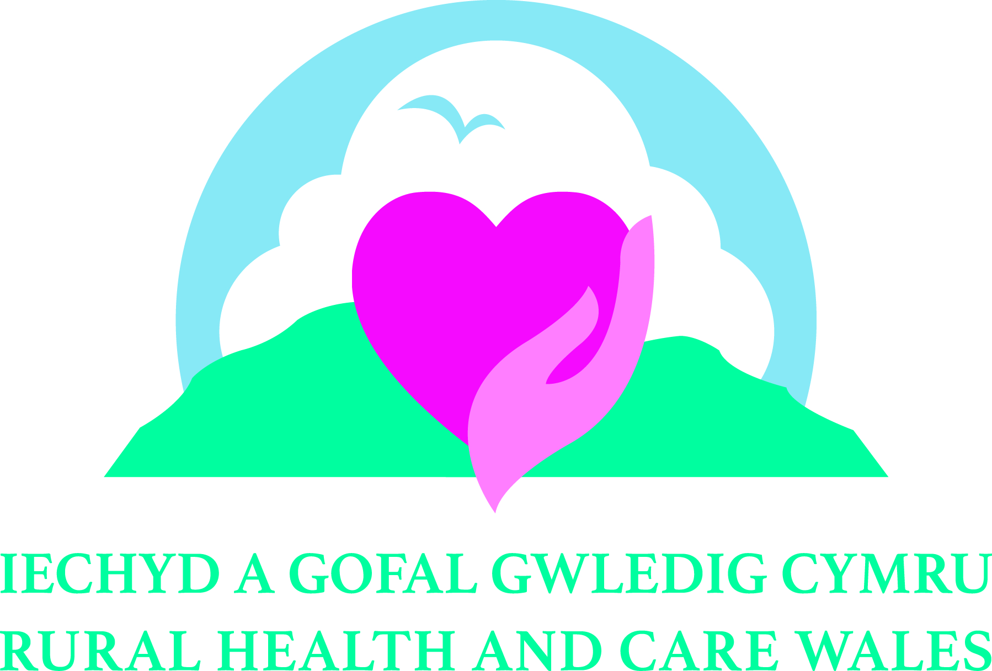
Rural Health and Care Wales
Conference 2025
Innovation and Improvement
– advances in the delivery of rural health,
care and wellbeing services
11 and 12 November 2025
CALL FOR PAPERS / POSTERS - APPLICATION FORM
Name*:

Job Title:

Organisation:

Are you a student? | YES / NO
Email Address:

Telephone Number:

Address: | Postcode:
Conference Strand  (please tick one): | □ The delivery of Integrated Health and Care services in Rural areas, including cross-sector, multi-agency and / or multi-disciplinary working  □ The role of Rural Communities and unpaid Carers in Health and Care  □ Advances in Artificial Intelligence (AI), Telehealth / Telemedicine and the remote delivery of Health and Care services in Rural areas  □ Social / Green Prescribing and the impact of Art, Crafts and other non-clinical interventions on Health and Wellbeing  □ Recruitment and Retention of Health and Care professionals in Rural areas  □ Education, Training and Continuous Professional Development for Health and Care professionals working in Rural areas  □ Addressing the broader Social Determinants of Health and the Preventative Agenda in rural health, care and wellbeing
Type of Presentation: | □ Paper (20 minute presentation) □ Poster
Title of Presentation:

Abstract –
300 words max.

Keywords / messages:  (6 max.) | 1.  2.  3.  4.  5.  6.
Co-presenter(s) information:  (if applicable) | - Name:  Job Title:  Organisation:  - Name:  Job Title:  Organisation:  - Name:  Job Title:  Organisation:
Biography of each speaker, including yourself:
(150 words max. per person)

Date of submission of application:

Signature:

Please return completed form to anna.prytherch@wales.nhs.uk
by 17.00 GMT, Friday 26 September 2025
* This should be the name and contact details of the main applicant. Please note all correspondence in relation to this application will be sent to the person named here.

