Family volunteering

Overview

- What is family volunteering?
- What are the benefits of family volunteering?
- How family volunteering makes an impact
- How to attract families to volunteer
- Things to consider
- Further information

Has your organisation considered inviting units of family members to volunteer with your organisation? This could me a larger family unit, such as two parents and their small children, a grandparent and a grandchild, or a guardian and a young adult in their care (as well as many other types of families).

The purpose of this information page is to enable organisations to understand how to include and develop volunteering opportunities for the whole family.

What is Family Volunteering?

Family volunteering allows families to contribute to their communities while spending quality time together. These opportunities are designed for family groups to work on a shared activity, whether it’s a one-off project or a regular commitment.

Examples of family volunteering activities:

- Tree planting and community gardening.
- Helping at local fairs and family-friendly events, hosting an activity or setting up/packing away.
- Participating in litter-picking days or conservation projects
- Assisting with charity fun runs or walks, by being volunteer marshals or cheering volunteers.

Did you know?

Family volunteering can help remove barriers like childcare, making it easier for parents and caregivers to participate in volunteer activities with their children.

What are the benefits of family volunteering?

Offering family-friendly volunteer roles can help your organisation grow, innovate, and connect more deeply with the local community.

Here’s how family volunteering can benefit your organisation:

- Diversifies your volunteer base, engaging new groups of volunteers
- Builds community connections and strengthens social cohesion
- Encourages lifelong volunteerism by inspiring children to become future volunteers
- Brings fresh energy and new ideas from multigenerational volunteers
- Raises awareness of your work and mission among local families
- Removes barriers like childcare, making volunteering accessible to more people

Did you know?

When families volunteer together, the responsibility for under-18s rests with parents or guardians. However, it’s still important to ensure you follow safeguarding practices.

How family volunteering makes an impact

Family volunteering strengthens family bonds, boosts wellbeing, and promotes a sense of community. It offers families the chance to step outside their daily routines, work together toward a common goal, and take pride in their shared achievements.

It also:

- Instils values of compassion, responsibility, and community in children
- Reduces screen time and increases physical activity (depending on the activity)
- Provides opportunities to socialise and meet other families

How to attract families to volunteer

Creating family-friendly opportunities means thinking about what families want and need. Keep your messaging clear, inclusive, and welcoming to families of all shapes and sizes.

Consider these tips:

- Flexibility is key – offer weekend or school holiday opportunities
- Make activities age-appropriate and easy for families to understand
- Provide clear role descriptions with expectations and tasks outlined
- Collaborate with local groups to co-host events and reach more families

Common reasons families volunteer together:

- Spending meaningful time together
- Meeting other families
- Learning about and supporting local causes
- Teaching children values and responsibility
- Having fun and trying something new

Things to consider

When planning family volunteering, take a few extra steps to ensure safety, clarity, and a positive experience for everyone involved:

- Parental/guardian consent is essential for under-18s.
- Check permissions for activities, such as council approvals for public spaces.
- Review your insurance policy to ensure it covers family volunteering.
- Conduct a risk assessment for each activity, considering the abilities of different age groups and the environment.

Further information

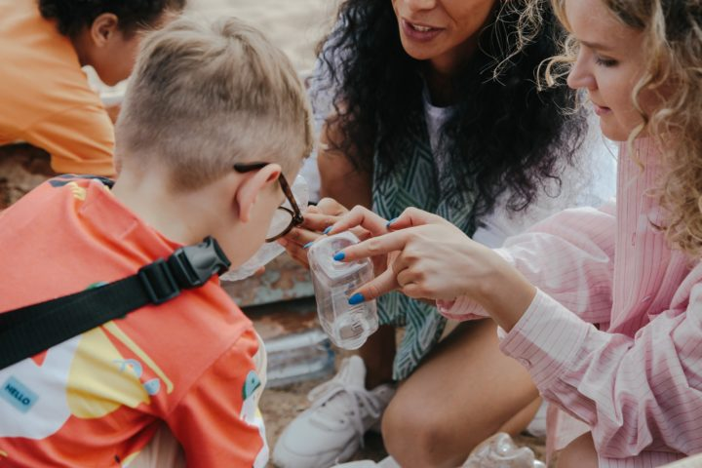

Family Volunteering Club

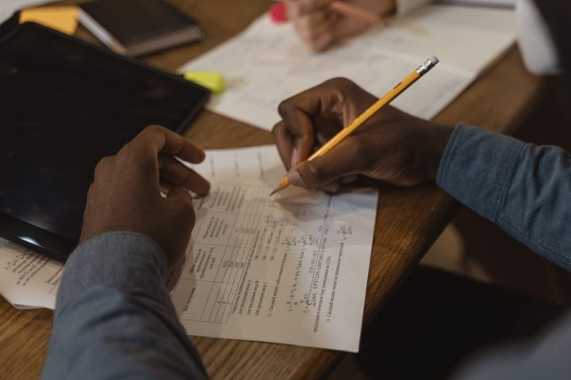

Volunteer Role Description



Safeguarding Policy Template



Risk Assessment

