Equality and diversity monitoring for volunteers: A good practice guide

Overview

The information on this page outlines the language of equality and diversity monitoring and enables you to better understand what data to collect, how to be GDPR compliant and where to go for further information.

On this page

- What does ‘equality and diversity monitoring’ mean?
- Benefits of equality and diversity monitoring in volunteering
- What data should organisations collect from volunteers?
- How do I collect and record information?
- Where do I record the information?
- GDPR compliance for volunteer diversity data
- What do I do with data collected?
- Our organisation doesn’t work with everyone, so do we need to monitor diversity?
- We only have a small number of volunteers; how can we collect it anonymously?
- Further information

What does equality and diversity monitoring mean?

Equality and diversity monitoring involves collecting ‘special category data’ about volunteers’ backgrounds.

It must be recorded, stored, used and updated in accordance with requirements set out in the Data Protection Act.

Information may be collected, for example, about race, gender, religion, age, disability, sexuality or language. Organisations must also ensure when collecting data that they are compliant with GDPR (General Data Protection Regulation).

Benefits of equality and diversity monitoring in volunteering

Monitoring this data can help an organisation to identify whether the diversity of their volunteer population reflects the diversity of the community they work in.

Did you know?

In Wales, the 2021 Census revealed that 6.2% of the population identifies as belonging to an ethnic minority group. If your monitoring data shows your volunteer base is only 2% diverse, you have a clear, data-driven mandate to adjust your recruitment strategy.

It can help to show whether there are any under-represented groups in your volunteer population so you can focus recruitment in these areas or adapt existing volunteer roles to encourage different types of volunteer to join.

It can also be a requirement of some funding applications to report on your current equality and diversity data for volunteers.

To get the fullest possible cooperation of volunteers in providing equal opportunities data, you need to make it very clear why you need this information, what you will be doing with it, who will have access to it, and how it will help your organisation to be more inclusive.

There is no legal requirement to collect this information for volunteers, but it is considered good practice because it demonstrates a commitment to providing equal opportunities to all volunteers.

What data should organisations collect from volunteers?

This can vary depending on the size of the project, its aims and the reasons for your monitoring. There is no need to collect data on all protected characteristics – think about your needs and what you will do with the data.

As a general guide, if you won’t be using the data then don’t collect it!

How do I collect and record information?

There are several different ways to do this. Some examples have been listed below, each with their limitations and advantages summarised. Some may suit your project or organisation better than others:

Collect and record information anonymously at recruitment – no names or addresses linked to it.

Advantages | Limitations
Completely anonymous, protects volunteers’ information | You can’t track changes to the data as your volunteer population changes (i.e. when a volunteer leaves you can’t identify their data to remove it)
Some volunteers more likely to give information if they can do so anonymously | As the project develops over time the data will be less accurate for your current volunteer population. Can’t pull off a snapshot of equality and diversity data for your current volunteer population
You can easily report on all volunteer equality and diversity data ever collected

Collect information with volunteer details at recruitment, but store separately with anonymous identifier.

Store equality and diversity data on a spreadsheet or database with an anonymous identifier code and store the code and volunteer details separately. When volunteers leave you can identify their code and remove their equality and diversity data from your data bank.

Advantages | Limitations
You can store information anonymously and safely | Complicated process – involving an intermediate administrative step of assigning codes and safely storing the list of codes assigned to names
You can remove information when a volunteer leaves to ensure your data is an accurate representation for your volunteer population | Relies on people remembering to remove data from volunteers that have left
You can create a snapshot of equality and diversity data for your current volunteer population

Annual collection of data in anonymous survey.

Collect equality and diversity data anonymously from volunteers with an annual volunteer survey.

Advantages | Limitations
All data is anonymous and shows a snapshot of a volunteer sample at the time of the survey | Only shows data for a sample of your volunteer population (i.e those who respond) not the entire population
Easy to collect and no concerns over storing information without using it | Can be difficult to encourage volunteers to complete the survey
Opportunity to record and report on other volunteer data to aid programme improvement e.g. customer satisfaction

Volunteer self-populated information.

Some online software allows you to give your volunteers secure online access to the database so that they can update the information themselves.

NB: A ‘prefer not to say’ option should be included in each case

Where do I record the information?

There are a range of options available that may be suitable for this:

- Specific volunteer management database (e.g. Volunteering Wales website)
- Bespoke Excel spreadsheet
- Specific fundraising database (e.g. The Raiser Edge)
- Online tools

The most important things to consider are how you will use that information once it is stored, what will work for your organisation, and what your organisational data protection policies require, in terms of data storage.

GDPR compliance for volunteer diversity data

- Individual organisations will have their own data protection policy, in line with current legislation, and any equality and diversity data should be collected and stored in accordance with legislation.
- This is confidential information, and so should not be available or accessible by the general public. Ideally it should not be available to anyone who does not need it for their job.
- Good practice is to make it a requirement for staff and/or volunteers who will have access to this information to sign up to a confidentiality policy.
- There should be an opt out, or ‘prefer not to say’ option available on the form. You must make it clear to volunteers why you are collecting this information.
- It is unethical to collect data if you will not use it

What do I do with data collected?

There are a number of uses for this data, including:

- Annual reports
- Highlighting under-represented groups so that future volunteer recruitment can be targeted
- Compare with local demographic data as a demonstration of organisational good practice and commitment to inclusion
- Often it is a requirement for grant applications and tenders to collect and submit this data



Our organisation doesn’t work with everyone, so do we need to monitor diversity?

Even if you work with a limited section of the population, such as students, or people affected by a health condition, you may still want to aim for the broadest diversity of volunteers that is compatible with your mission. If so, you will need to monitor this.

It may be more appropriate to compare your volunteer diversity with that for a relevant target population (such as the student population, or the population of those affected by a named health condition), rather than data for the local community as a whole.

We only have a small number of volunteers; how can we collect it anonymously?

Handling Equal Opportunities data in the case of small numbers of volunteers can be a challenge because of the risk of individuals being recognisable in any report or analysis of the data.

There are three possible suggestions for overcoming this:

- Accumulate data over several years to increase total numbers. It can then be analysed for volunteers over say, a 5-year or 10-year period, on a rolling basis
- Pool volunteer data with staff data to increase total numbers and report on a combined basis

Carry out simple analysis only, by observing, describing and identifying where under representation exists. It may be, for example that you can identify under-representation in terms of language, geographical area, age or gender when your volunteer team is compared with the clients that you seek to ‘match’ them with or to reflect.

Once you have identified under-represented groups across your volunteer base, see the ‘Three steps to diversify your volunteer base’ for tips on next steps.

Further information



EDI in Volunteering: A guide to equality, diversity and inclusion for volunteer managers

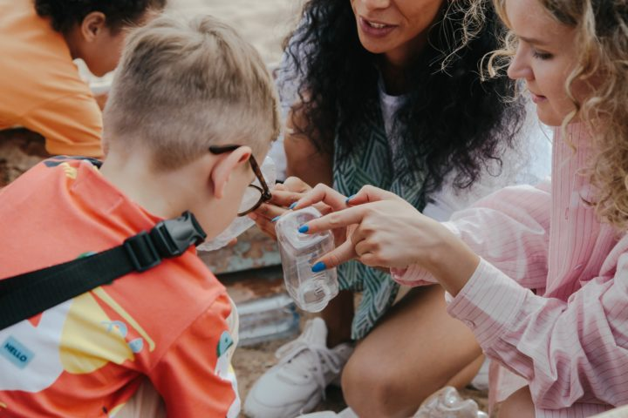

Involving asylum seekers and refugees in volunteering



Involving volunteers with learning disabilities, learning difficulties, or additional support needs



Involving young people as volunteers



Investing in Volunteers

