EDI in volunteering: a guide to equality, diversity and inclusion for volunteer managers

The information on this page outlines the language of equality, diversity and inclusion and explains how these principles apply to volunteering to help create a more inclusive and appropriate experience for all volunteers.

On this page

- What is equality?
- Does the Equality Act 2010 apply to volunteers?
- What is diversity?
- Why create inclusive environments?
- The benefits of diversity within organisations
- Three steps to diversity your volunteer base
- Welcoming volunteers on board – making reasonable adjustments
- Creating inclusive spaces for diverse volunteers
- Learning from experience
- Further information

What is equality?

Equality is about treating people fairly, ensuring that they have equitable access to opportunities and resources, regardless of:

- Age
- Disability
- Gender reassignment
- Marriage or Civil Partnership
- Pregnancy or maternity
- Race
- Religion or belief
- Sex
- Sexual orientation

This list is known as ‘protected characteristics’

Does the Equality Act 2010 apply to volunteers?

The Equality Act 2010 requires organisations to act in ways that are transparent, consistent and fair, regardless of individuals’ identity or background and whilst this legislation does not specifically cover volunteers or trustees, organisations may be responsible for their volunteers’ discriminatory actions where they are acting on behalf of an organisation.

Furthermore, there is a moral and ethical imperative for organisations to interact with volunteers in ways which uphold principles of equality and inclusion, including;

- Being proactive in reducing barriers that prevent certain sectors of communities from getting involved in volunteering
- Being vigilant in addressing discriminatory behaviours, whether this be the behaviour of staff, volunteers, or service users

What is diversity?

Diversity is about recognising and celebrating difference. It goes beyond ‘fair play’ and compliance and focuses on creating an ethos that values and welcomes the unique qualities and perspectives of each individual.

Embracing diversity means drawing upon the widest possible range of views, backgrounds and experiences, so that an organisation can listen to, and meet, the changing needs of its users, staff, volunteers, trustees, partners and supporters.

Why create inclusive environments?

Creating an inclusive environment can help counteract prejudice against a wide range of personal difference including those protected characteristics which are addressed by equality legislation and also, for example;

- Level of qualification
- Accent, language
- Physical and mental abilities
- Political affiliation
- Mental ill health
- Spent or irrelevant convictions, and
- Trade union affiliation

Inclusion is the practice of ensuring that people feel a sense of belonging and support from the organisation. It is about the behaviours, and social norms that ensure people feel welcome.

When involving volunteers or trustees, organisations are encouraged to take a proactive approach to inclusion, seeking to understand how volunteering opportunities can be as inclusive and accessible as possible by removing barriers and provide appropriate support. Different individuals may require different approaches to ensure volunteering is inclusive.

What are the benefits of diversity in volunteering?

Involving a wide diversity of volunteers and trustees leads to more diverse organisations which is beneficial for,

- Presenting a welcoming face – ensuring volunteers, client groups and the general public see themselves reflected in you organisation
- Community representation – ensuring your internal culture matches the diversity of the community you serve
- Service relevance – improving your ability to understand and respond to the specific, evolving needs of the local community
- Recruitment, retention and wellbeing – improving volunteer recruitment, satisfaction, ongoing support for the cause and improved volunteer wellbeing
- Building a diverse talent pipeline – creating a pathway for volunteers from diverse backgrounds and abilities to gain the experience needed to transition to paid staff or trustee roles

Three steps to diversity your volunteer or trustee base

Research on volunteering consistently indicates that inequalities of resources and power mean that some people are more likely to be excluded from certain activities.

While having a diversity statement or policy is an important starting point, it is not sufficient on its own. Increasing diversity requires a strategic, organisation-wide approach that includes the following aspects:

1. Create an inclusive culture

Organisations should aim to build an inclusive culture before recruiting a more diverse volunteer or trustee base. This may include:

- Ensuring staff, trustees and volunteers receive appropriate training.
- Reflecting on organisational systems, practices and public image to identify real or perceived barriers to inclusion.
- Proactively exploring why certain groups may be under-represented in the organisation’s staff, trustee or volunteer base.

2. Be intentional with volunteer and trustee recruitment

Diversifying the volunteer or trustee team requires targeted and intentional recruitment that reduces existing barriers.

Key considerations include:

- What languages is the organisations using or making available?
- What impression does the publicity material give?
- Are the messages inclusive?
- Is there visible diversity in the imagery and online presence?
- Where and how the volunteer or trustee opportunities are advertised?
- Who is likely to see the adverts?
- Is the language, message and approach appropriate for the target audience?

Monitoring the diversity of volunteers and trustees and analysing the data to identify under-represented groups will help inform the recruitment strategy and future planning.

Did you know?

The Time Well Spent report found that volunteers with disabilities were more likely to be online than non-disabled volunteers, suggesting that digital platforms may be an effective way to offer accessible opportunities.

3. Curate flexible and person-centred volunteering experiences

Review the needs of the organisation and curate volunteering and trustee opportunities that appeal to a wide spectrum of people.

Consider:

- Do the volunteering experiences appeal to people of different ages, genders, lived experiences, abilities and motivations?
- Is there flexibility across roles to adapt the responsibilities or co-design the role to best meet the individual interests and abilities?
- Is there an offer of both one-off/short-term roles and regular ongoing commitments?
- Can some roles, or aspects of them, be carried out from home or virtually?
- Are roles flexible enough to be adapted to meet different capabilities and accessibility needs?

Welcoming volunteers on board – making reasonable adjustments



Make sure you welcome all the volunteers and offer them a positive and tailored induction to the organisation. You might consider introducing a mentoring or buddy scheme, to help those new to the organisation to feel more connected and that they belong.

Training and induction methods will need to take into account that people learn in different ways. Consider and check out how comfortable the volunteer is with, for example, reading long documents or speaking aloud in a group. A variety of training methods is advisable alongside flexibility in using alternative approaches when necessary, including making reasonable adjustments where needed.

Volunteering should be, from the volunteer’s perspective, informal, satisfying and ‘user-friendly’. Too much bureaucracy and ‘small print’ can easily exclude and deter people. Recent research in the Time Well Spent survey indicates that for too many volunteers, volunteering can feel too similar to work. However, ‘behind the scenes’ organisations will ideally have in place rigorous management processes to ensure volunteering is safe, supportive, effective and impactful.

From the outset, consider volunteers’ needs for support and supervision. This will vary according to the role, and according to the needs and personality of the volunteer. Ask volunteers if they have any particular changes to access requirements and discuss ways in which these might be addressed. For example, think about how you can modify equipment or adapt the volunteer role in a way which meets an individual’s needs and creates opportunities for success and impact.

Creating inclusive spaces for diverse volunteers

When making arrangements for volunteering, including place of volunteering, meetings, events and activities, consider the effect of your decisions on the entire volunteering group. For example,

- Is the time and date of the volunteering appropriate for all volunteers? Does it fall at a time when younger volunteers are in education or on a day of cultural significance? Could there be different date and time options for volunteers?
- Is the location of the volunteering accessible to all? This will also need to be considered if it is a virtual venue. Do volunteers have the skills, confidence and equipment to access online spaces?
- Are there costs to volunteers to access volunteering? Will they need to pay for transport, food, access to particular software, like a Zoom account, to be able to take part. If so can the organisation cover these expenses? Is prompt payment possible for volunteers?
- Are staff and other volunteers trained and supported to understand and reflect on Equality, Diversity and Inclusion? Are there any behaviours or ways of working that could make others feel excluded? Have you thought about how the organisation could support all staff and volunteers to feel comfortable?

If there are likely to be changes that will affect volunteers (i.e. moving all volunteering online or using a new procedure), think about how these changes could affectexisting volunteers, whether these changes will still be inclusive and ensure communications about the changes can be accessed and understood by all volunteers. Involve volunteers in the development of the organisation (including its diversity strategies) by asking for their input to the discussion and decision making.

Consider how an ethos of diversity is nurtured within the organisation? Recent research indicates that younger people, people with disabilities and those from ethnically diverse communities are more likely to be dissatisfied with their volunteering experiences. Consider therefore, how the organisation can work towards being more accessible and supportive to people from diverse backgrounds.

Learning from experience

Creating an open and inclusive culture helps to create a positive and harmonious working and volunteering environment. However, things do sometimes go wrong. When they do arise, problems need to be handled with care, and lessons can often be learned from them.

Many organisations have mechanisms to gather staff and / or volunteer feedback and insights. Ensuring that all volunteers can access and contribute to these processes helps organisations continuously improve how they manage and support volunteers.

All volunteers should be made aware of how to raise a concern or complaint, and who to contact. They should also understand what is expected of them and the process that will follow if inappropriate or discriminatory behaviour occurs.

When volunteers leave, for whatever reason, the organisation may gain valuable insight into their experience, including any negative aspects, by offering an exit interview or similar feedback opportunity.

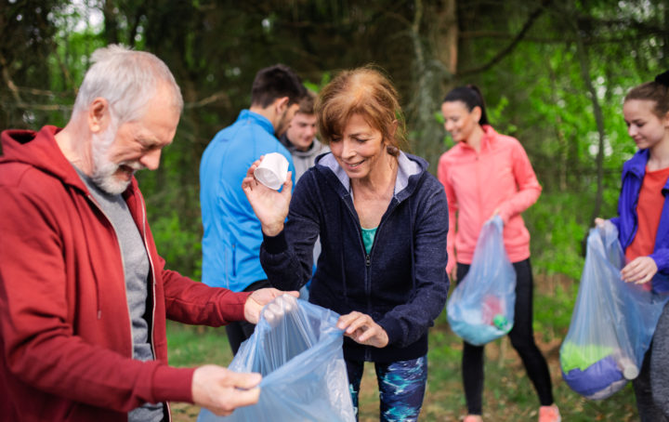

Managing volunteer exits

Further information



Equality and diversity monitoring for volunteers: A good practice guide



Investing in Volunteers



Anti-racist Wales Action Plan



Time Well Spent Survey

