Devolution and powers

Overview

- Introduction
- Legislative powers
- Fiscal powers
- What this means for the voluntary sector

Introduction

Devolution is a process, not an event.

Established in 1999 as the National Assembly for Wales, the Senedd has gradually gained additional powers. The Government of Wales Act 2006 paved the way for a referendum in 2011, in which a majority of voters supported granting the then Assembly full law-making powers.

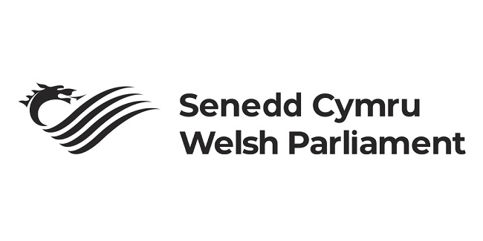

Further powers were devolved under the Wales Act 2014 and the Wales Act 2017. The 2014 Act gave Wales tax-raising powers for the first time. The 2017 Act shifted Wales from a conferred powers-powers model, where the Senedd and Welsh Government could act only in explicitly devolved areas, to a reserved powers-powers model, in which the Senedd can legislate on any subject unless it is specifically reserved to the UK Parliament.

At the next Senedd election, scheduled for May 2026, the Senedd will expand from 60 to 96 Members and adopt a new electoral system. For more information, see our explainer on electoral reform.

Legislative powers

The Senedd and Welsh Government have powers in a wide range of policy areas, including:

- education
- health
- transport
- planning
- economic development
- social care
- culture
- the Welsh language
- the environment
- agriculture and rural affairs

They can propose policies in all of these areas and in any other area not explicitly reserved to the UK Government. This includes the ability to make new laws, known as primary legislation. Proposals for new laws, called bills, can be introduced by:

- the Welsh Government
- individual Senedd Members (MSs)
- Senedd committees
- the Senedd Commission



All bills must be approved by the Senedd before becoming law.

When primary legislation is passed, it may include powers for Welsh Government Cabinet Secretaries and Ministers to make subordinate (secondary) legislation. These laws are made under powers delegated by the Senedd or, in some cases, the UK Parliament. Subordinate legislation typically includes statutory instruments such as regulations, orders, rules, schemes, guidance, or local orders. Some of these require Senedd approval.

The UK Parliament retains responsibility for several reserved matters, including:

- defence and foreign affairs
- policing and criminal justice
- the constitution
- employment law
- charity regulation and fundraising
- consumer protection

Fiscal powers

The Welsh Government is funded through a combination of:

- an annual block grant from the UK Government
- Welsh taxes
- limited borrowing powers

The block grant is calculated using the Barnett Formula. In 2024–25, the Welsh Government’s budget was approximately £23 billion. The Welsh Government is not required to follow UK Government spending plans and can set its own budget, subject to Senedd approval.

The Barnett formula

The Barnett Formula determines how changes in UK Government spending in England affect Wales’s block grant. If the UK Government increases or decreases spending in a devolved area, such as health, the Welsh Government receives a proportionate rise or fall in funding. Spending changes in non-devolved-devolved areas, such as defence, do not affect the block grant.

Tax powers

Following the Wales Act 2014 and the Wales Act 2017, the Senedd and Welsh Government gained control over several Welsh taxes, including:

- Landfill Disposals Tax
- Land Transaction Tax (previously known as Stamp Duty)

The Welsh Government has also introduced new Welsh taxes, such as the Visitor Levy often referred to as the ‘tourist tax’.

Wales also has partial control over income tax. The Welsh Government can vary income tax rates by up to 10 pence in the pound. For example, it can set the basic rate anywhere between 10p and 30p. Unlike Scotland, Wales cannot create new tax bands or alter thresholds. To date, the Welsh Government has chosen to keep rates aligned with those set by the UK Government.

Borrowing powers

Since 2014, the Welsh Government has been able to borrow up to £500 million to address shortfalls in devolved tax revenue.It can also borrow up to £1 billion for capital investment, with an annual limit of £150 million. Capital borrowing can be used for projects such as new infrastructure, construction, or major maintenance.

What this means for the voluntary sector

When seeking to influence government, it is essential to understand which level of government holds responsibility for your area of interest. Most day-to-day services in Wales, such as health, housing, education, social care, and local government, are devolved. However, important areas such as policing, criminal justice, and welfare remain reserved to the UK Parliament and Government. Understanding where powers sit helps ensure you direct your influencing efforts to the right place, saving time and increasing impact.

Understanding where powers sit helps ensure you direct your influencing efforts to the right place, saving time and increasing impact.

It is also important to consider how accessible different institutions are. Generally, the Senedd is smaller and more open than the UK Parliament. You are far more likely to meet a Senedd Committee Chair or a Welsh Cabinet Secretary than their UK Government equivalent. The Senedd’s expansion after the 2026 election will likely create further opportunities for engagement.

This does not mean you should avoid influencing Westminster. Rather, it highlights the importance of understanding the different structures and access points within Wales’ and the UK’s political institutions so you can tailor your approach effectively.

