**How do I find volunteers?**



**Volunteer centres/strong>**

There is a Volunteer Centre in every county in Wales which provides support at a local level for volunteering, for individual volunteers and for volunteer involving organisations. They have six core functions:

* Promoting and Celebrating Volunteering
* Develop Good Practice
* Develop Volunteering Opportunities
* Policy and Campaigning
* Strategic Development of Volunteering
* Brokerage service matching people with volunteer opportunities

Your local volunteer centre can help you in developing your volunteer practice and in recruiting volunteers.

[Volunteering Wales](http://www.Volunteering-Wales.net) is a central, Wales wide digital system used by all the Volunteer Centres to promote volunteering across Wales. You can register your opportunities here for free to reach thousands of prospective volunteers.



**What do volunteer centres do in Wales**

Our information sheet What do volunteer centres do in Wales explains more about the work on Volunteer Centres.

**Volunteer recruitment process**

When a volunteer opportunity arises you should follow a recruitment process to publicise the opportunity and select your volunteer.

It’s a good idea to put together a volunteer information pack that you can share with any prospective volunteers. This doesn’t need to be a long document but it should tell them enough about your organisation and the opportunity so they can decide whether the organisation would be right for them.

You can include the role description you have written for the volunteer opportunity in this pack.

**Publicise your volunteer opportunity**

In order to attract the widest range of people to your organisation we would recommend that you publicly advertise your volunteer opportunities. While it is great to have volunteers that join due to personal recommendation that doesn’t always create the widest reach for your volunteer recruitment or attract a diverse range of people.

To publicise your volunteer opportunity you will need to create an advert. This should set out:

* what your organisation does and what cause or group of people it benefits
* the difference the volunteer will make to the cause
* what the volunteer will get from their involvement
* if you will pay expenses and what this will cover
* who they can ask questions about the role
* how they can find out more.

You should then use the advert to promote the volunteer opportunity. Where you advertise the role may depend on the type of volunteers that you are hoping to attract. Promoting the opportunity on your social media, newsletter or website will help you reach people who are existing supporters or already aware of your organisation but it is likely that you will need to advertise more widely to reach new people.

You could also think about putting your advert in local community venues, such as community centres or libraries or public buildings, or try shop windows or community noticeboards (which you can also find on social media). If you are hoping to attract young people then try asking schools, colleges and universities if they can help.



**Volunteering Wales**

The Volunteering Wales website is a free online platform that voluntary organisations across Wales can use to promote their volunteering opportunities. You can register and create a profile page for your organisation and add any volunteer opportunities as and when they arise.

**Selection process**

The selection process you adopt will depend on your organisation and the activities that volunteers undertake within it. All organisations need to establish a system that will not only suit their needs, but one that does not put unnecessary barriers in the way of potential volunteers.

The selection process should be a two-way process. It should enable the organisation to decide on the suitability of potential volunteers while enabling volunteers to decide whether they feel suited to the organisation.

If you decide to use a volunteer application form, then be clear about what information you need and why you need it. Keep the form as simple as possible. Consider what mechanisms you can put in to allow people with different support needs to apply.

As part of the application process you will be dealing with personal information about the people that are applying for your volunteering opportunities and must comply with data protection legislation. If you use a form for ‘equalities monitoring’ and ask questions about protected characteristics then responses are likely classified as ‘Special Category Data’ and are afforded more protection under the UK General Data Protection Regulations. This shouldn’t put you off collecting the information though. It is better to put data protections in place and understand how widely your opportunities reach. For more information on this take a look at our information sheet Equality and Diversity Monitoring for Volunteers.

You are likely to want to get to know something about the person before appointing them as a volunteer. You could ask them for an ‘interview’ but that term might be too formal and off putting so inviting them in for a ‘chat’ might be better. Make sure you have explained the purpose of any meeting to the potential volunteer so they know what to expect and are prepared.

When meeting with a potential volunteer you may wish to cover the following areas:

* What attracted them to your organisation
* What experience they may have, including any lived experience
* What, if any relevant skills, knowledge and interests they have
* Are there any health considerations or support needs relevant to their volunteering which require adaptations or reasonable adjustments
* What their expectations might be and what they hope to gain from volunteering
* Confirm the times/days they are likely to be available

**Final checks**

Before you take the final step and appoint a volunteer you should consider the need for any final checks on their suitability for the role. We recommend that you take up references as part of the recruitment process.

If the volunteer role involves working with adults at risk or children or young people, you may need to undertake a DBS check. You can find more information about this in our DBS section.



**Recruiting Selecting and Inducting Volunteers**

Our information sheet Recruiting Selecting and Inducting Volunteers contains more information to help you with the volunteer recruitment process.

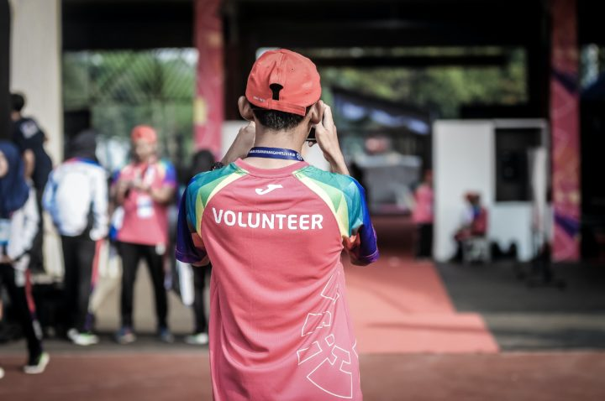

**Management and Support for Volunteering**

Our information sheet Recruiting Selecting and Inducting Volunteers contains more information to help you with the volunteer recruitment process.