What is governance?



Starting Out

In this section we are looking at what you need to know and what you need to do to make sure your group is governed effectively.

It’s very important that you understand governance, especially if you want your group to develop into an organisation and get access to funding.

There are two key things that you will need to have in place as a starting point for the governance of your group:

- Enough people who are willing to act as a committee to manage the group and who may later become trustees
- A written constitution or governing document to provide a set of rules for the way your group is run

For more information about the things that you should consider when starting your group take a look at our Getting started section.

Definition of governance

Governance is about the leadership and direction of an organisation and the way it is run. Governance has been defined as:

The systems and processes concerned with ensuring the overall direction, effectiveness, supervision and accountability of an organisation.

(The Governance of Voluntary Organisations, Cornforth 2003)

It is important to understand that governance is different to management.

- Governance is the term used for the matters to do with controlling the organisation and taking overall responsibility for it
- Management is the day-to-day management of operational matters that do not need to be carried out by the trustees and can be delegated to staff or volunteers

The trustees of an organisation are legally responsible for its governance.

Four strands of governance

In a well-governed organisation, the board and governance structure will provide:

- Direction – showing leadership by setting strategy. Being clear about what the organisation is aiming to achieve and how
- Effectiveness – making good use of the charity’s money and resources. With a focus on achieving their desired outcomes
- Supervision – making sure the charity follows the law, its governing document and policies and, where issues arise, they are dealt with quickly. Considering potential risks, and monitoring progress to keep the organisation on track. Learning from mistakes or difficulties and making changes where needed.
- Accountability – reporting to those who are interested in what the organisation is doing, including regulators.

What does good governance look like in practice?

If your organisation has good governance then you can be sure that:

- The organisation complies with legal and regulatory requirements
- The organisation is run within the objects, powers and procedures set out in its governing document
- A strategic plan is created by the trustees to ensure the organisation’s survival and growth
- Operational procedures are developed to deliver the organisation’s objects
- The trustees exercise their duty of care by pursuing sound business practices in running the organisation
- The trustees act prudently by ensuring the organisation’s continuing solvency, making best use of its assets and managing risks.

It can be helpful to think about governance as a set of principles for running an organisation. There are codes of governance that have been created to set standards for different types of organisation.

Key governance principles

Nolan Standards of Public Life

The Nolan Standards of Public Life is one of the most famous set of standards. It outlines seven principles of public life

- Selflessness
- Integrity
- Objectivity
- Accountability
- Openness
- Honesty
- Leadership

These standards (also called the Nolan principles) apply to anyone working in the public sector or delivering public services. They have also been adopted in the voluntary sector as principles that should be followed in running an organisation. You can find more information on the Nolan principles here.

The Charity Governance Code

The UK Charity Governance Code is a code of good practice that has been created ‘by the sector, for the sector’ and is designed to help trustees maintain high standards of governance in their charities.

The Code is deliberately aspirational. It contains a set of seven key principles which ensure that the highest possible standards of governance are set and those principles have been designed to be universal and applicable to all voluntary, community and not-for-profit organisations. Each principle is accompanied by a rationale, key outcomes and recommended practice.

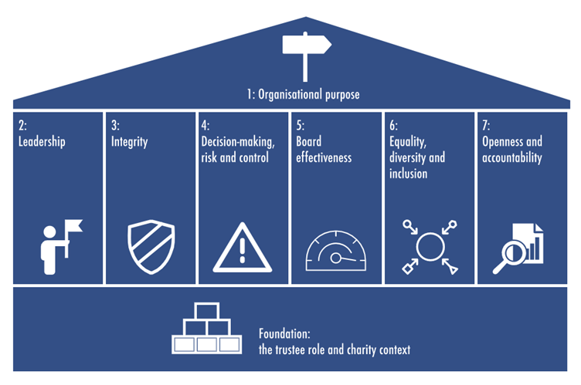

There is a version of the Code which has been created for smaller charities. There is also a template that you can use to work through the points in the Code to assess your current levels of governance and identify areas of improvement. This template can appear quite daunting so we would suggest that you have a look at one area at a time and work to improve your governance step by step.

You will find the Charity Governance Code and the template here.

