Safeguarding essentials

What is safeguarding?

Safeguarding is the term we use to mean the work we do every day to keep people safe and to prevent incidents of harm, neglect and abuse from occurring.

Safeguarding involves taking preventative measures to keep people safe, and also having appropriate procedures in place to respond to an incident after it has happened. All voluntary groups should be thinking about safeguarding their staff, volunteers and all people that come into contact with their organisation. Special considerations apply to those groups that are working with children and young people and / or adults at risk.

In this section we take you through the safeguarding requirements and provide some helpful links to resources and sources of support.

Safeguarding is for all voluntary groups

All voluntary organisations depend on people coming together and giving up their time to make their projects happen. To ensure that it is safe for everyone to take part, a number of reasonable measures should be agreed and put in place. Some measures will be preventative, and others will be reactive – “what if this happens?” – and many steps can be considered before you “open your doors”.

Safeguarding should be a key consideration in the way that you run your organisation and activities and guidance on this is available from Welsh Government and the Charity Commission;

- The Welsh Government states that safeguarding is everyone’s business, which means that we all have a role to play, however small, in keeping people safe. Community and voluntary organisations, faith, sports and social groups involve and include many people who are in difficult circumstances, and often know more about them and their needs than more formal agencies. Welsh Government released a code of safeguarding practice in 2022 to support all organisations to put safeguarding measures in place.

- The Charity Commission also emphasises the importance of safeguarding. The Commission says that all charities, and organisations operating for charitable benefit, have a role in safeguarding all the people who come into contact with them, not just those in contact with people traditionally considered at risk. This is a useful model for all voluntary organisations, especially those who may look for charity status at some point in time. The Commission provides a range of guidance for trustees (and those who run organisations). These people are held ultimately and collectively responsible for safeguarding, as the decision-makers for the organisation.

Many voluntary organisations may not focus directly on the needs of people; you may support an animal sanctuary or be concerned with the environment. However, you are likely to have volunteers, engage with the general public in some way, and possibly have staff. This means that you must consider safeguarding.

Related Resources

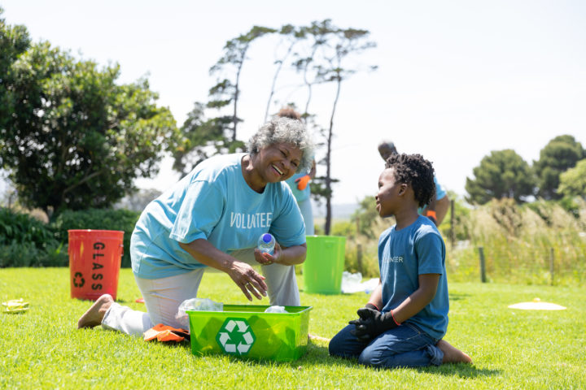

Introduction to Safeguarding in the Voluntary Sector Course

Our free e-learning course gives more information on the regulatory framework and key aspects of organisational safeguarding.

Other useful information

The Welsh Government Code of Safeguarding Practice

The main piece of legislation relevant to safeguarding is the Social Services and Well-Being (Wales) Act 2014, (‘the Act’) implemented in 2016, which involves us all in the well-being duty which includes protection from abuse and harm.

For resources about the Act including an Essentials and easy-read guides go to:The Social Services and Well-being (Wales) Act (2014)

Safeguarding of children and adults is found in Part 7 of the Act:with a range of statutory guidance volumes

