National Principles for Public Engagement

How to use this document

This is an easy read version. The words and their meaning are easy to read and understand
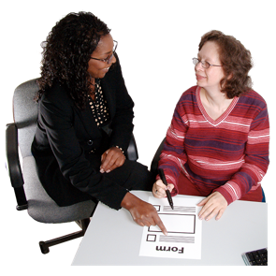

You may need help and support to read and understand this document. Ask someone you know to help you.

Some words may be difficult to understand. These are in bold blue writing and have been explained in a box below the word.

If any of the words are used later in the document they are shown in normal blue writing.

Pictures will be used to help you understand what the document says

This document was made using Photosymbols.

Overview

This document is split into 3 parts:
- Introduction
- Principles
- Definitions

Introduction

The National Principles for Public Engagement are 10 things for organisations and services to think about when they need to talk to and engaging with members of the public and people who use their services.
National Principles for Public Engagement are a list of 10 things to help organisations talk and include people better

In this document the National Principles for Public Engagement will be called ‘The Principles’

The Principles have been made for many different organisations and services to use.
Services

This includes people in Government, people who make decisions about services and people who deliver services

The Principles ask that all these people make a promise to use them and help people join in with their work

If these people use The Principles in the right way, it will mean that members of the public and people who use services will be able to take part in decisions that affect them

The Principles have been made by different organisations and people who do engagement work working together
Engagement Work is when people who provide services talk and listen to people who use their services

These organisations are:
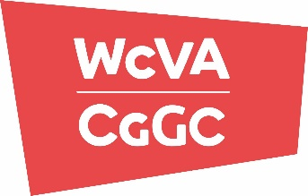
- Wales Council for Voluntary Action (WCVA)
Wales Council for Voluntary Action is the national membership body for voluntary organisations in Wales

- Co-Production Network for Wales
Co-Production Network for Wales is a community of people who believe in the value of co-production

- Welsh Local Government Association
Welsh Local Government Association represents the interests of local government and promotes local democracy in Wales

- Officer of the Commissioner for Future Generations
Officer of the Commissioner for Future Generations is part of the team that looks after the work done as part of the Future Generations (Wales) Act, 2016

- Welsh Government
Welsh Government is the Government for Wales

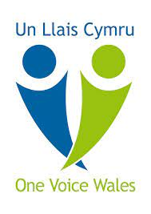
- One Voice Wales
One Voice Wales is the organisation for community and town councils in Wales

Principles

This section will explain each of the 10 things to help organisations and services talk to and do engagement work with people better

- Plan your engagement to make a difference

This means that organisations and services should make sure that members of the public and the people who use their services have a chance to share their stories and ideas to make things better

The National Principles for Public Engagement ask organisations and services to think about these things:

- What can be done with the information that is collected

- What type of engagement will help them get the information they want

- How to share information about the engagement so that they know why it is being done

- How to make sure that they are listening to lots of different people when they do their engagement

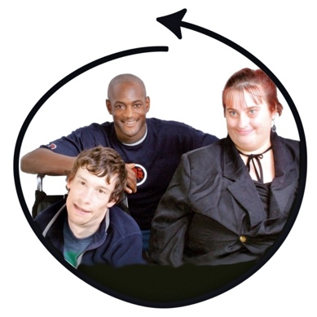
- Invite people to get involved, if they choose to

This means that people should have the opportunity to take part as an individual or as part of a group or community

It also means that people don’t have to take part and that it is their choice

The National Principles for Public Engagement ask organisations and services to think about these things:

- How to make sure that they are listening to lots of different people when they do their engagement – this also means thinking about reasonable adjustments that might be needed to help those people take part in the work
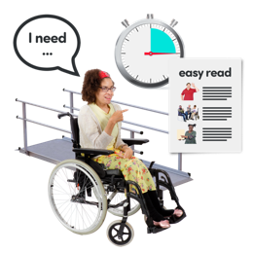
Reasonable adjustment is a change that organisations and services have to make to help people join in with work and activities in a way that meets their needs

- Making sure people have a choice to take part or not to take part
- How to find the people who have experience or might be affected by the work

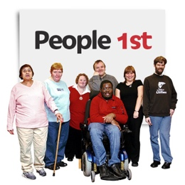
- How to work with groups that are already running

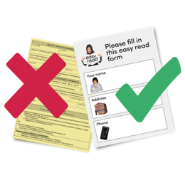
- Making sure that the way they share information about the engagement is accessible and right for the people they want to work with

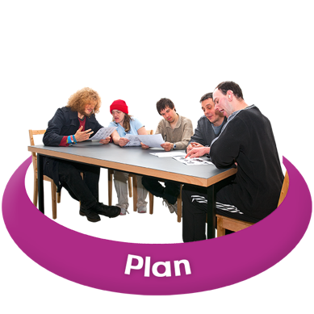
- Plan and deliver your engagement in a timely and appropriate way

This means that how the engagement is going to be done should be planned properly, and that everyone who takes part is told the plan in a way they can understand

It also means that people should know how long the engagement work will take and that it is done in the best way to get the information that is needed

The National Principles for Public Engagement ask organisations and services to think about these things:

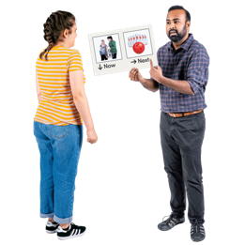
- How their engagement work can be done at the right time and not left to the end

- What other plans and work are there that the engagement can help, like making decisions or writing policies

- What type of engagement will help them get the information they want

- Who can help them find the people who need take part in the engagement work

- How they can use different types of engagement to help different people take part – reasonable adjustments

- How the people who take part in 1 part of the engagement work can be given the opportunity to take part in other parts of the work

- Work with relevant partner organisations
Services

This means that different organisations and services need to be able to talk to each other and share information
They need to do this to make sure that people’s time is being used in the best way

The National Principles for Public Engagement ask organisations and services to think about these things:
- Find out if they, or another organisation already has the information that is needed

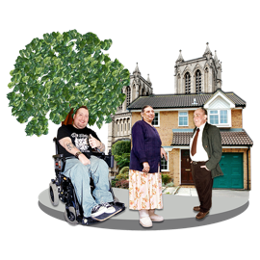
- Work with other organisations who are doing the same sort of work as them, or are working in the same place as them

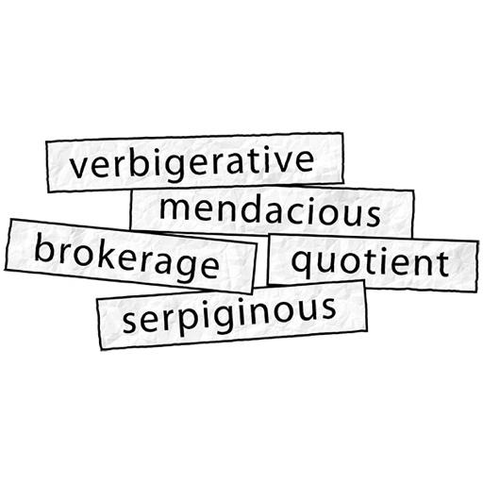
- Provide jargon free, appropriate, and understandable information

This means that organisations and services should think about their audience and make sure the information they produce doesn’t use Big Words and is shared in a way that people understand

The National Principles for Public Engagement ask organisations and services to think about these things:
- How the information will look

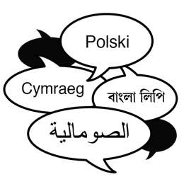
- Using different languages like English, Welsh and BSL

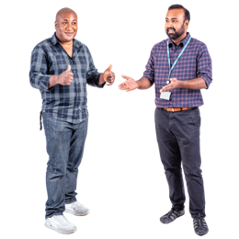
- Making sure that the information is okay for different cultures and religions

- Making sure they don’t give people too much information all at once

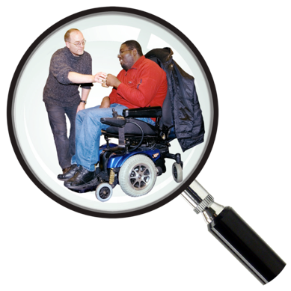
- Make it easy for people to take part

This means that organisations and services should look for things that might stop people being able to take part and find ways to remove them

The National Principles for Public Engagement ask organisations and services to think about these things:

- Who they want to take part in the work

- What might stop people being able to take part

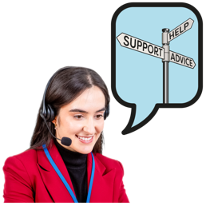
- What can help different people to take part
- How to give people a chance to say what might stop them taking part

- If they are doing work online how can they make sure different people can take part

- What access if there to buildings where activities will happen

- What transport is there to get to activities

- How can they work with other organisations to get support for different people to take part
Services

- Ensure people benefit from the experience

This means that when people take part in the work they should also get something good from it

This could be things like skills, confidence and meeting new people

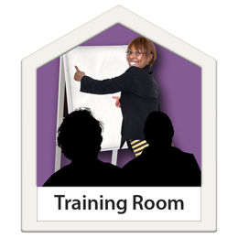
The National Principles for Public Engagement ask organisations and services to think about these things:

- How they can help people to get new skills or confidence by taking part in the work

- How can they work with other organisations to get support for different people to take part
Services

- How they can make people feel respected and listened to

- How they can thank people for taking part

- Ensure the right resources and time are in place for your engagement to be effective

This means that organisations and services should give enough time to plan their work to make it meaningful
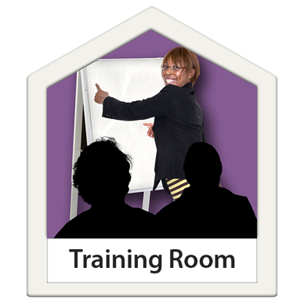
This also means that they should think about things like training and what else is needed to make the work happen

The National Principles for Public Engagement ask organisations and services to think about these things:
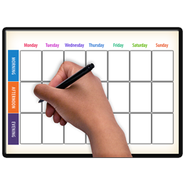
- How to give different people the time they need to be able to do the work properly
- That there is enough time and money to do all of the work

- Who is going to lead the work to make sure it happens
Leader

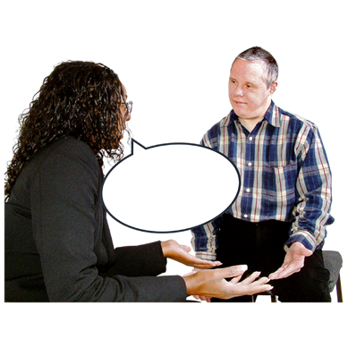
- Let people know the impact of their contribution

This means that organisations and services should give people feedback about the work

The National Principles for Public Engagement ask organisations and services to think about these things:

- When to give people feedback after they take part

- The best way to give feedback to different people

- How to share information about what has been done and to explain to people why some things might not have happened

- Learn and share to improve your engagement

This means that organisations and services should think about what went well and what didn’t go well so they can make good changes for future work

The National Principles for Public Engagement ask organisations and services to think about these things:

- How they will review the work as it happens and when it has finished

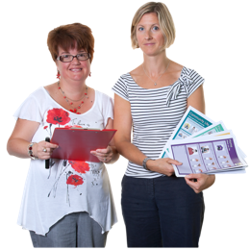
- How to share what you find out with the people who take part in the work

- How to create a good way of working for the future

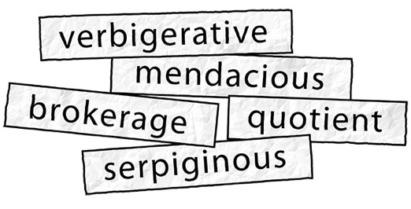
Definitions

This section explains 5 hard words that are used when doing engagement work

Engagement
Engagement is when people who provide services talk and listen to people who use their services to find out how things can be changed or made better

There are lot of different ways that engagement can be done and organisations and services should try to do engagement in different ways to suit people’s needs

Consultation
Consultation is a formal process where organisations and services ask people for their views on a topic or piece of work

Participation
Participation people are taking part to help organisations and services make decisions

Co-production
Co-production is when people and organisations and services work together as equals from the start to the end of the work

Involvement
Involvement means that organisations and services need to be ready to listen to people and work with people instead of doing things to them

This can also means that people should be supported to help find problems and ways to fix those problems in all parts of the work

The National Principles for Public Engagement were reviewed and published in 2022
Published means that something has been made available for people to see and use

